Dance
The Greatest Showman

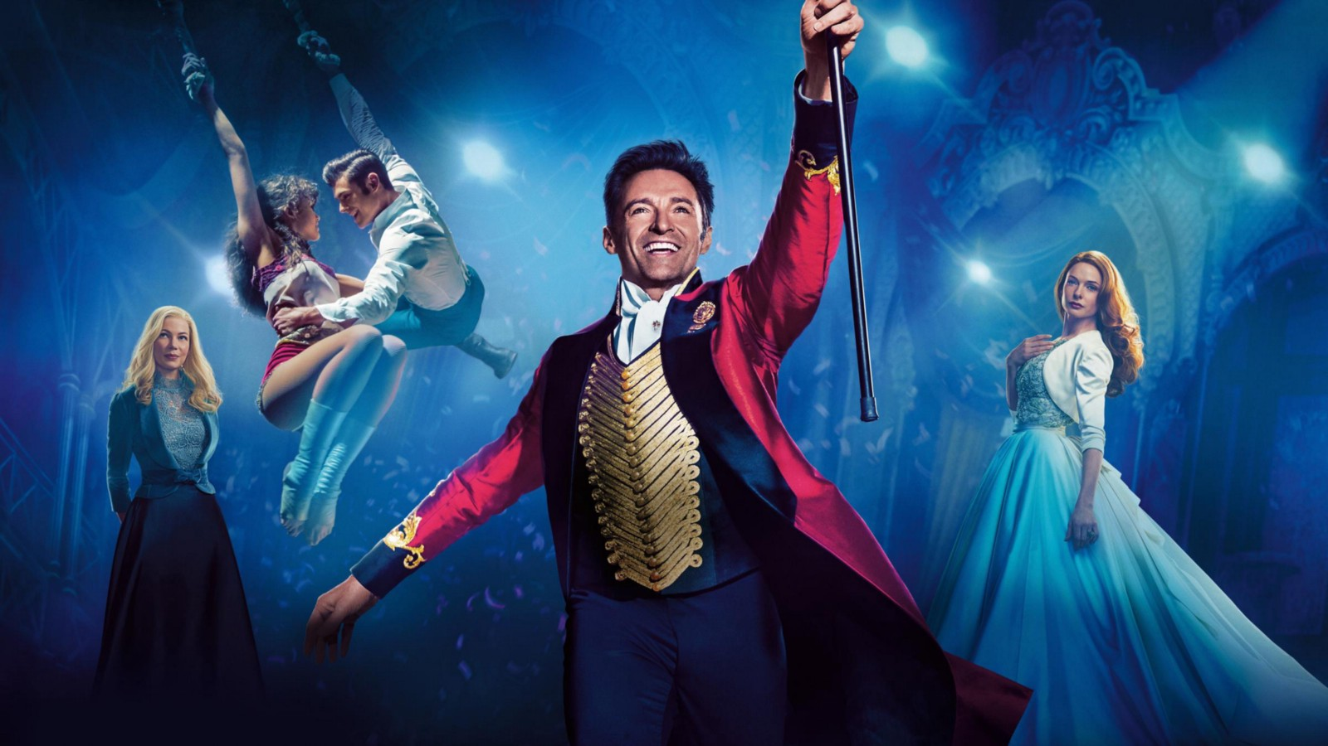

Name: ____________________

Tutor Group: __________________

If you have any questions or need any support with this booklet, please email Miss Malins fmalins@montsaye.northants.sch.uk

Key Word | Definition
Contemporary Dance | A dance style known for its storytelling ability, emotions and complicated movement sequences.
Choreography | Dance movements and sequences.
Unison | Performing actions at exactly the same time as other performers.
Accuracy | Performing the movement exactly as it was taught and the same as other dancers.
Transition | A linking movement between different sections of choreography.
Stimulus | Something that inspires the creation and content of a performance.
Timing | Moving at the same time as other group members and the beat of the music.

Video link to the performance of “The revolt” which features in The Greatest Showman: https://www.youtube.com/watch?app=desktop&v=Rj4Yu9Utdw0
The Greatest Showman research challenge:

1. What emotions do the performers demonstrate?

2. What gestures are used to convey messages through dance?

3. What is a motif?

4. What is the role of a Choreographer?

A steady or held position achieved by an even distribution of weight.
Balance
Alignment

Ability to maintain physical and mental energy over periods of time.
Stamina
The way the body is held.
Posture
The range of movement at a joint. The ability to move fluently from one movement to the next.
Mobility
An independent movement of part of the body.
Isolation
The range of movement at a joint.
Flexibility
Co-ordination
Extension
Lengthening one or more muscles or limbs.
Effectively using more than one body part.
The ability to start and stop movement, change direction and hold a shape efficiently
Control

Poster Activity: The Greatest Showman are looking for a new performer to join the show. Create a poster advertising the audition. Include the skills required to successfully perform this dance.

Challenge Plus: Include examples from the work.
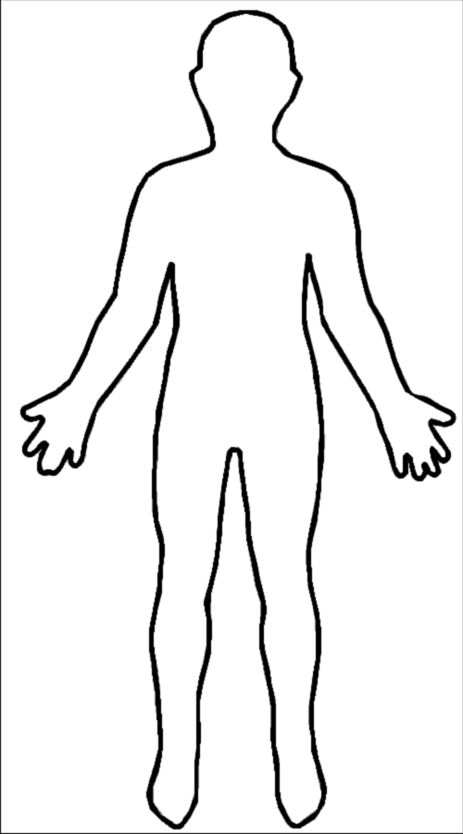
Costume Activity: Draw and annotate a costume from The Greatest Showman

Extension: How did the performance shown in the revolt video interact with props to convey their message.
Choreography Challenge: You will be planning your own dance motif inspired by Greatest Showman.
Choreography Key Terms:
Skills for Choreography
Relationship Content
Lead and Follow
Mirroring
Action and reaction
Accumulation
Complement and contrast
Counterpoint
Contact
Formations
Action Content:
Travel/ Turn/ Elevation/ Gesture/ Stillness/
Use of different body parts/ Floor work/ Transfer of weight/ turn/ hop/ Leap
Dynamic Content
Fast/ Slow
Sudden/ Sustained
Acceleration/ deceleration
Strong/ light
Direct/ indirect
Flowing/ abrupt
Choreographic devices
Repetition
Unison and Canon
Spatial content:
High/ Medium/ Low Levels
Small and big movement
Different Pathways
Facing different directions

Task: Complete the timeline on the next page with your own motif (describe or sketch it). Remember to annotate your timeline using your choreography key terms.

Choreography timeline
What formation have you decided to use to perform motif in? (Describe or sketch it below)

Why have you decided on this formation?

_________________________________________________________________________________________________________________________________________________________

If you would like to take part in extra-curricular activities within the PE department – please see our timetable of activities below.
