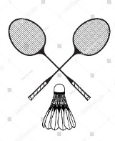
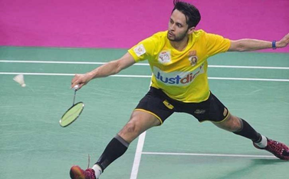
Badminton
Challenge 3: On the diagram below, shade in the areas in which you can score in a game of singles and doubles. Remember, these are slightly different (Singles is the top half of the court, doubles is the bottom)

Challenge 4:
A: Label the court markings on the picture below
(Service line/side tramlines/back tramlines/net/centre line).
B: State the court dimensions

Challenge 2: State all the different ways in which you can score a point in badminton.

Challenge 1: Explain 5 basic rules of badminton
1.

2.

3.

4.

5.

Singles

Doubles

Challenge 1 – Wall rally  See how many times you can hit the shuttle against a wall without letting it hit the ground. If you don’t have a racket or shuttle use your hand and a ball! | Challenge 2 – Agility  Place 5 items (plant pots/stones/footballs/toilet rolls!) 3 meters apart in any shape you chose. Get somebody to time you touching each item as quick as possible.  To make it harder, make the shape bigger and complete it more than once per go
------------ ----------- | 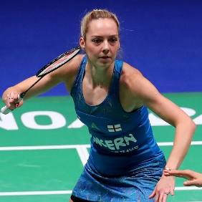  Challenge 3  Identify these 4 badminton players. Use YouTube and Google to help you.  ------------ ------------
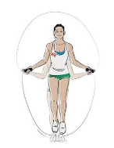  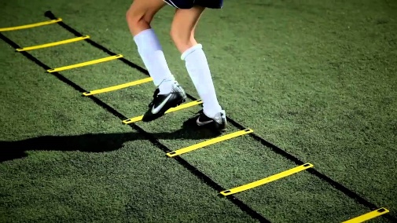  Challenge 4 – Skipping  To practice those quick feet, design a skipping circuit using the different kinds of skips (research if you need to) and carry it out. If you don’t have a skipping rope create and complete your own agility course to improve our footwork! | 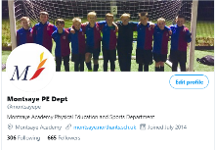  Challenge 5 – Smile!  Get pictured completing any badminton challenge and tweet @monstaype
Let’s Practice Some Skills

Teamwork
This term you have had a focus on improving the Montsaye’ s value of Aspiration. You have done this by learning about developing Teamwork. Below is what is expected from a Year 8 student in relation to teamwork skills. Take time to reflect and give an example of how you have demonstrated each of these in your Badminton lessons.
Example of Teamwork | Example when you have demonstrated this in Rugby
Give 2 examples of when you have demonstrated respect to a team mate, opposition player or referee during your rugby lessons.

Explain why in a team game such as rugby, it is important for excellent teamwork to be demonstrated.

Explain how verbal communication can improve teamwork and group success.

Using an example, explain what would happen to a team’s performance if communication was poor

Explain how non-verbal communication can improve teamwork and group success.

Using an example, explain what would happen to a team’s performance if non-verbal communication was poor.

If you would like to take part in extra-curricular activities within the PE department – please see our timetable of activities below.
