Rugby Union
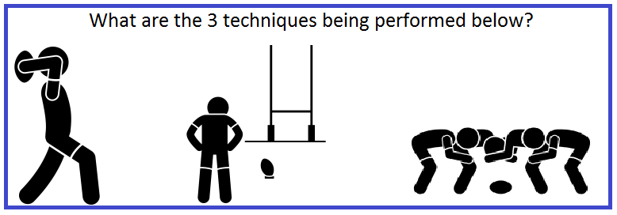
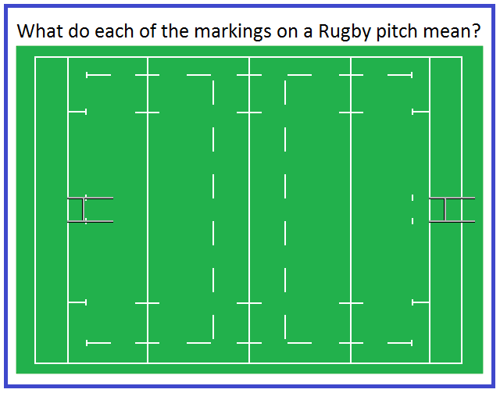
How many Points do you get for scoring the following?
1. Try
2. Conversion
3. Penalty
4. Drop Goal

How many players are there on a Rugby Union team and what number would a Hooker and Fly half wear?

Describe 5 key rules in Rugby
1.

2.

3.

4.

5.

Challenge 1  Find out what a ‘grubber kick’ is and attempt this over 5/8/10m  +Attempt with non-dominant foot  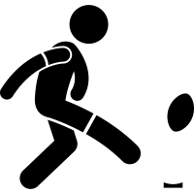 | Challenge 2  Perform 30 seconds of lateral passing with a partner in both directions (left & right)  + Increase the distance
Challenge 3  Practise your try scoring technique. You must apply downward pressure on the ball  +Research Chris Ashton’s famous try scoring technique on YouTube | Challenge 4  Dustbin Drop Goal  Research how to perform a drop goal and attempt this from 5m.  +Increase distance to 7/9m and attempt with non-dominant foot  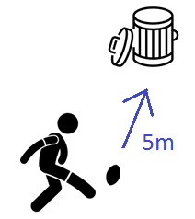
Challenge 5  Identify who these famous England payers are and what position they play. Look up footage of them on YouTube | Challenge 6  Get pictured completing any challenge and tweet @montsayepe  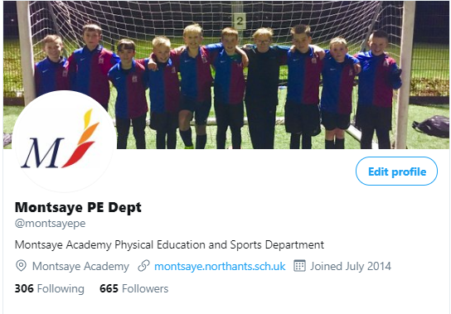
Rugby Union Challenges
Teamwork
This term you have had a focus on improving the Montsaye’ s value of Aspiration. You have done this by learning about developing Teamwork. Below is what is expected from a Year 7 student in relation to teamwork skills. Take time to reflect and give an example of how you have demonstrated each of these in your Rugby lessons this term.
Example of Teamwork | Example when you have demonstrated this in Rugby
Name 3 skills which are important to be able to demonstrate good teamwork

Describe a time you have demonstrated good teamwork in a rugby lesson.

Using the example you provided above, explain what happened as a consequence of your good teamwork.

Give 2 examples where you used verbal communication skills to give feedback to another person / team.

Give 2 examples where you used non-verbal communication skills to give feedback to another person / team.

If you would like to take part in extra-curricular activities within the PE department – please see our timetable of activities below.
