**LO1 – Deadline – Fri 23rd Sept.**

Solutions to barriers

1.

2.

3.

4.

5.

6.

7.

8.

What are the different What potential barriers

user groups? might they face?

1.

2.

3.

4.

5.

6.

7.

8.

Notes:

Name organisations that work to increase provision and popularity of sport.

Recent years has shown a growing interest in which sports?

What are emerging sports?

Factors affecting participation in sport

LO2 – Sporting Values - Deadline 7th October

Sporting initiatives and what they are trying to achieve.

Define sporting etiquette:

Example:

Define spectator etiquette:

Example:

What is the Olympic creed?

………………………………………………………………………………………………………………………………………………………………………………………………………………………………………………………………

What do the 5 rings represent?

……………………………………………………………………………………………………………………….

Sportsmanship VS Gamesmanship

Sportsmanship is: …………………… Gamesmanship is: …………………..

……………………………………………….. …………………………………………………

……………………………………………….. …………………………………………………

Sporting examples: Sporting examples:

**Olympic & Paralympic** Values What do they mean?

1.

2.

3.

4.

5.

6.

7.

**Sports** Values What do they mean?

1.

2.

3.

4.

5.

6.

7.

Reasons against use:

Examples of PED’s

Reasons for use:

Previous offenders and their sport:

What are they?

………………………………………………………………

……………………………………………………………….

………………………………………………………………

……………………………………………………………….

**Performance Enhancing Drugs (PEDs)**

The ‘Whereabouts’ rule is:

………………………………………………………………

……………………………………………………………….

………………………………………………………………

……………………………………………………………….

LO3 Hosting Major Sporting Events – Deadline 11th November

**Identify some benefits of hosting major sporting events and decide whether it is an economic, social or sporting benefit**.

What is meant by the term ‘Legacy’?

…………………………………………………………………………………………………………………………………………………………………………………………………………………………………………………………………………………………………………………………………………………………………………

Sporting:

Social:

Economic:

The 3 types of Sporting Event

**Definition:**

**Examples:**

**Definition:**

**Examples:**

**Definition:**

**Examples:**

Benefit Legacy

**Benefits and Drawbacks of hosting a major sporting event**

Benefits Drawbacks

LO4 – National Governing Bodies



What are NGB’s?

……………………………………………………………………………………

…………………………………………………………………………………....

……………………………………………………………………………………

**Promotion**

How is it done? ........................

……………………………………………….

E.g. …………………………………..

How is it done? ……………………

……………………………………………….

E.g. …………………………………..

How is it done? ……………………..

……………………………………………….

E.g. …………………………………..

**Funding**

What sources of funding can NGB’s provide?

**Infrastructure**

What do NGB’s offer?

1)

2)

3)

4)

5)

**Development**

What do NGB’s develop? Give an example of each.

1)

2)

3)

**Support**

How do NGB’s offer support?

**Policies and Initiatives**

Give examples of Policies and Initiatives. How do they impact sport?

1) 3)

2) 4)

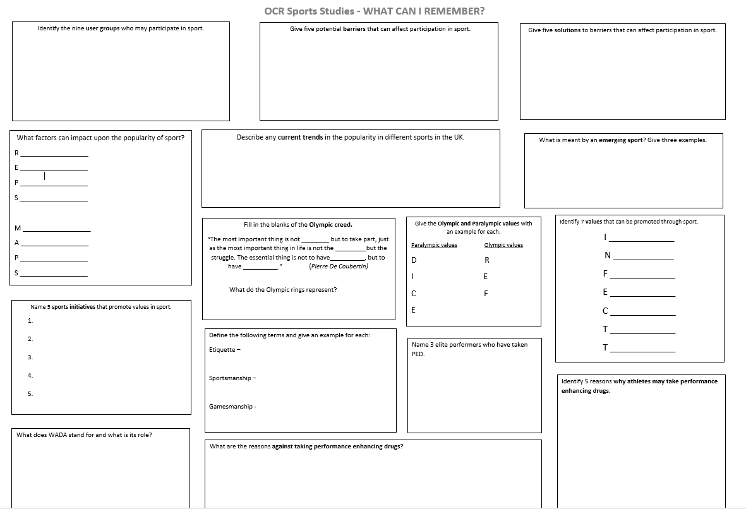

**Exam knowledge recall – Deadline 2nd December**

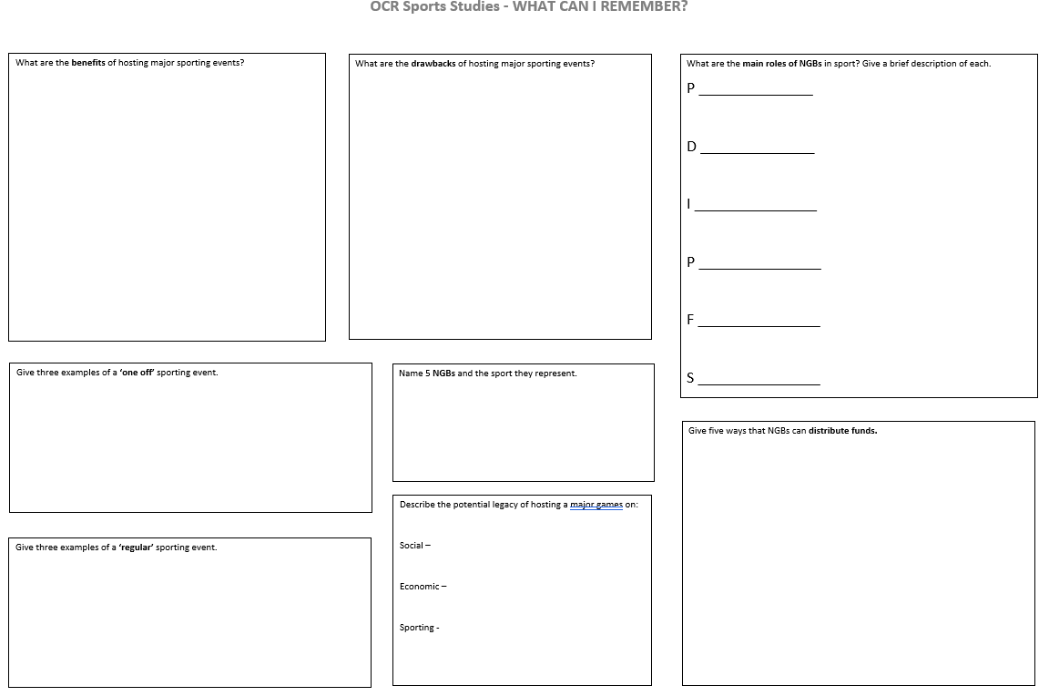

**Exam knowledge recall – Deadline 16th December**